CASE STUDY: [Name]
Project name
Location
Project Partners | [Developer, architect, contractor]
Building Type | [Housing, office, school]
Size | [in sq. m]
Project status | [Completed, in planning]
UKGBC Work Area | Advancing net zero

Net Zero Framework Principles: [Case studies should demonstrate innovative approaches that are aligned with the principles of the Net Zero Carbon Buildings Framework. Please delete as appropriate the relevant areas of the framework.]
 |  |  |  | 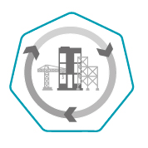
Construction | Operational Energy | Renewables | Offsets | *Whole life carbon
* Distinct from construction – A whole life approach utilises life-cycle analysis to minimise carbon impacts throughout all stages of the building lifecycle – including construction, operation, refurbishment and end of life. This would include addressing in-use and end-of-life embodied carbon.
Project overview
[A summary paragraph about the project, its context and background]
Highlights
- [Key achievements and outcomes of the project in bullet-point form]
{pictures}
Approaches used
- [Key approaches used to achieve the above, such as the technologies used and technical specifications]

For further Information:
Please contact: [relevant contact for further information on the project]

